Lab Exercise 4–Provisioning an EC2 Instance on AWS

Name-Garvit janu
SAP ID- 500119646 Batch-3
Exercise Steps:
Step 1: Create a New Directory:
Create a new directory for your Terraform configuration:
“Terraform-Demo”
Step 2: Create Terraform Configuration File (main.tf):
Create a file named main.tf with the following content:
terraform {
required_providers {
aws = {
source = "hashicorp/aws"
version = "5.31.0"
}
}
}
provider "aws" { region = "ap-south-1"
access_key = "your IAM access key" secret_key = "your secret access key"
}

This script defines an AWS provider and provisions an EC2 instance.
Step 3: Initialize Terraform:
Run the following command to initialize your Terraform working directory:
terraform init
Step 4: Create Terraform Configuration File for EC2 instance (instance.tf):
Create a file named instnace.tf with the following content:
resource "aws_instance" "My-instance" { ami = "ami-03f4878755434977f" instance_type = "t2.micro"
tags = {
Name = "MY-EC2-Instnace"
}
}
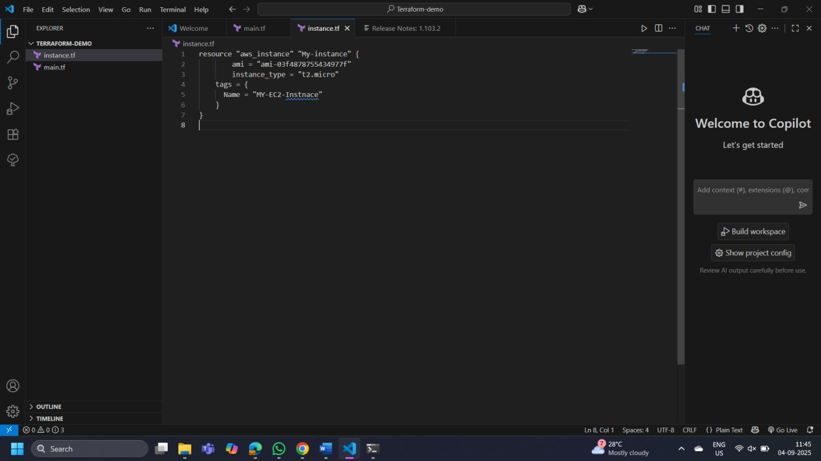
Step 5: Review Plan:
Run the following command to see what Terraform will do:
terraform plan
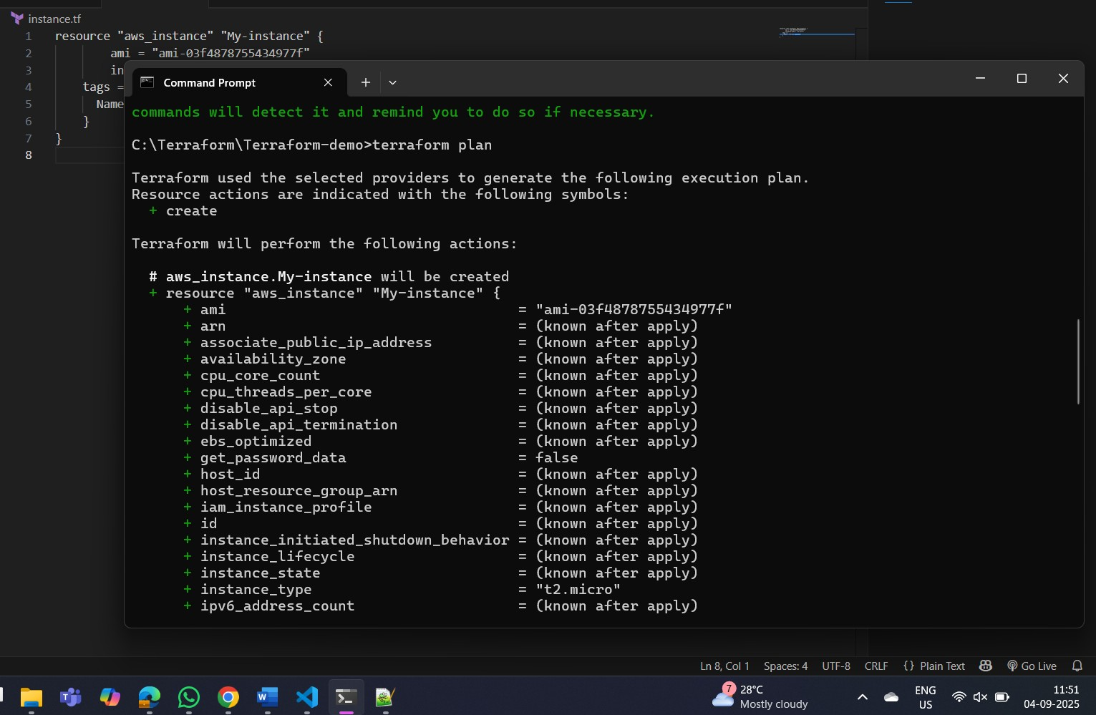
Review the plan to ensure it aligns with your expectations.
Step 6: Apply Changes:
Apply the changes to create the AWS resources:
terraform apply
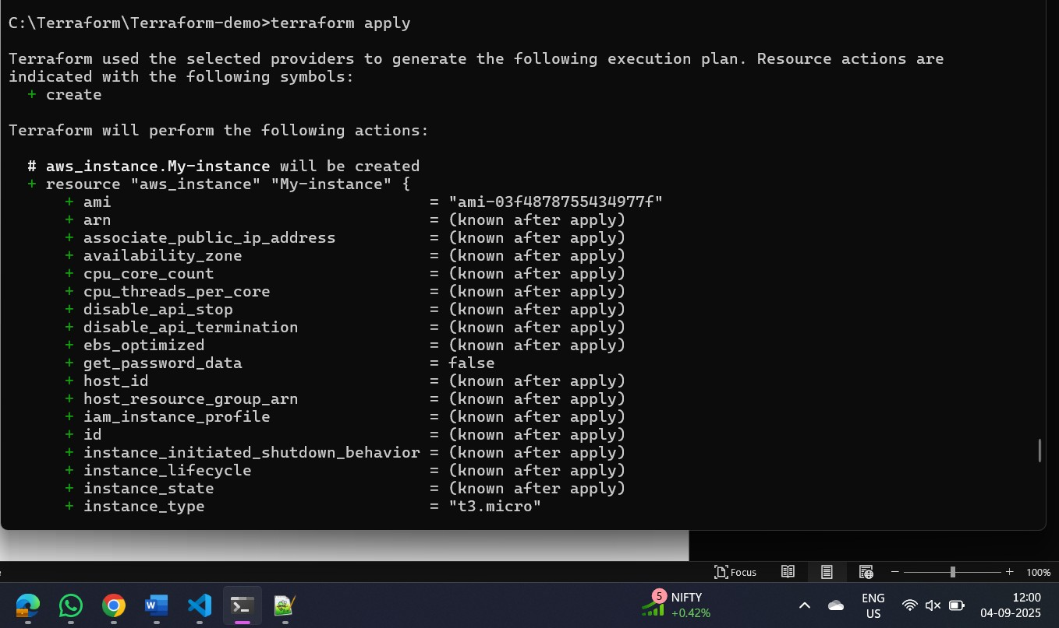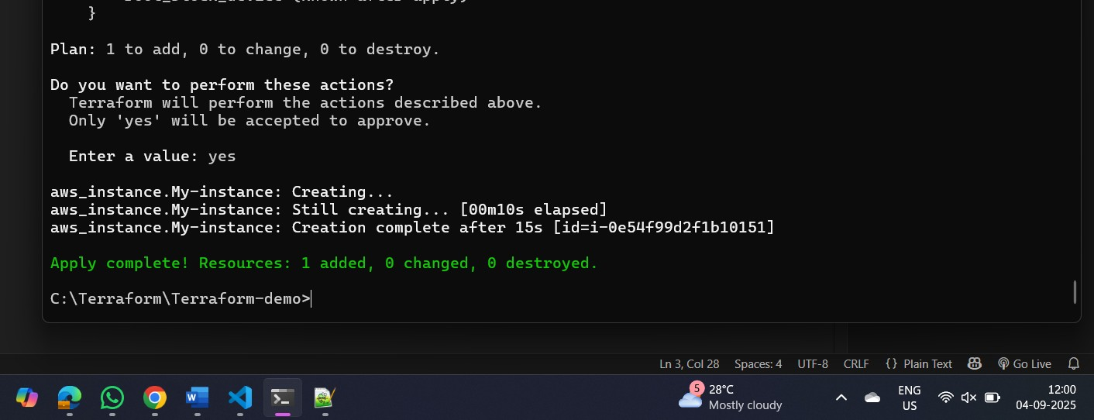
Type yes when prompted.
Step 7: Verify Resources:
After the terraform apply command completes, log in to your AWS Management Console and navigate to the EC2 dashboard. Verify that the EC2 instance has been created.
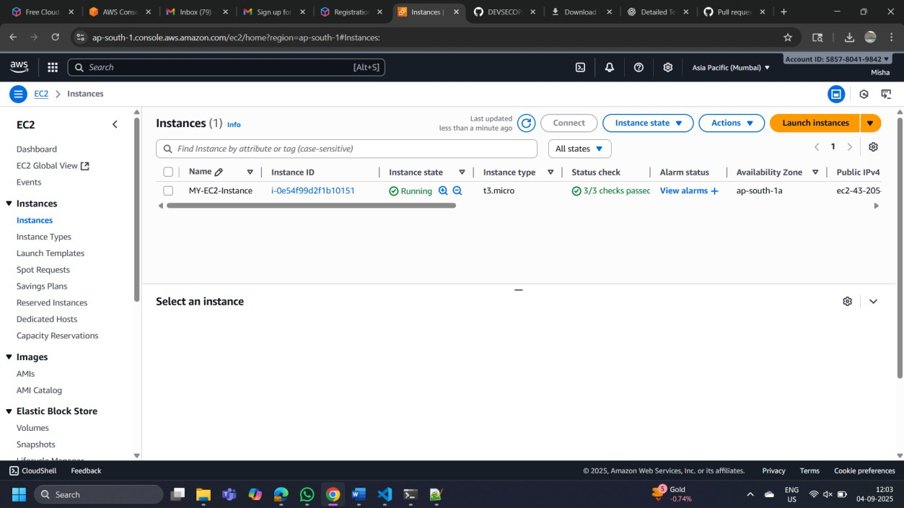
Step 8: Cleanup Resources:
When you are done experimenting, run the following command to destroy the created resources:
terraform destroy
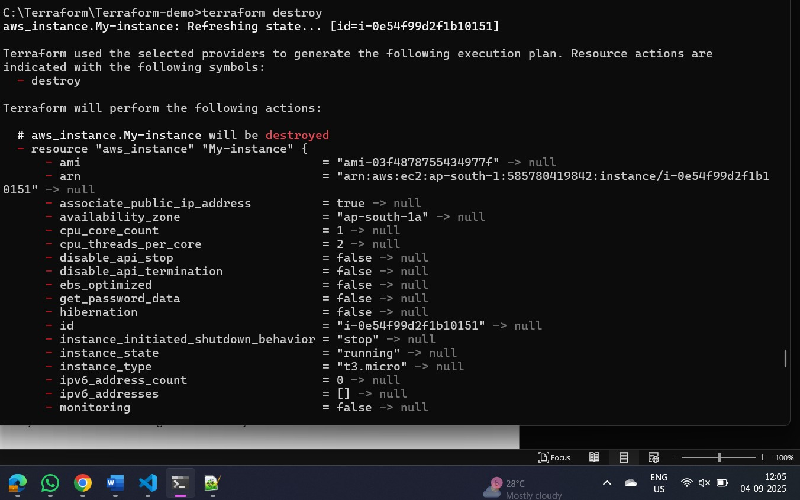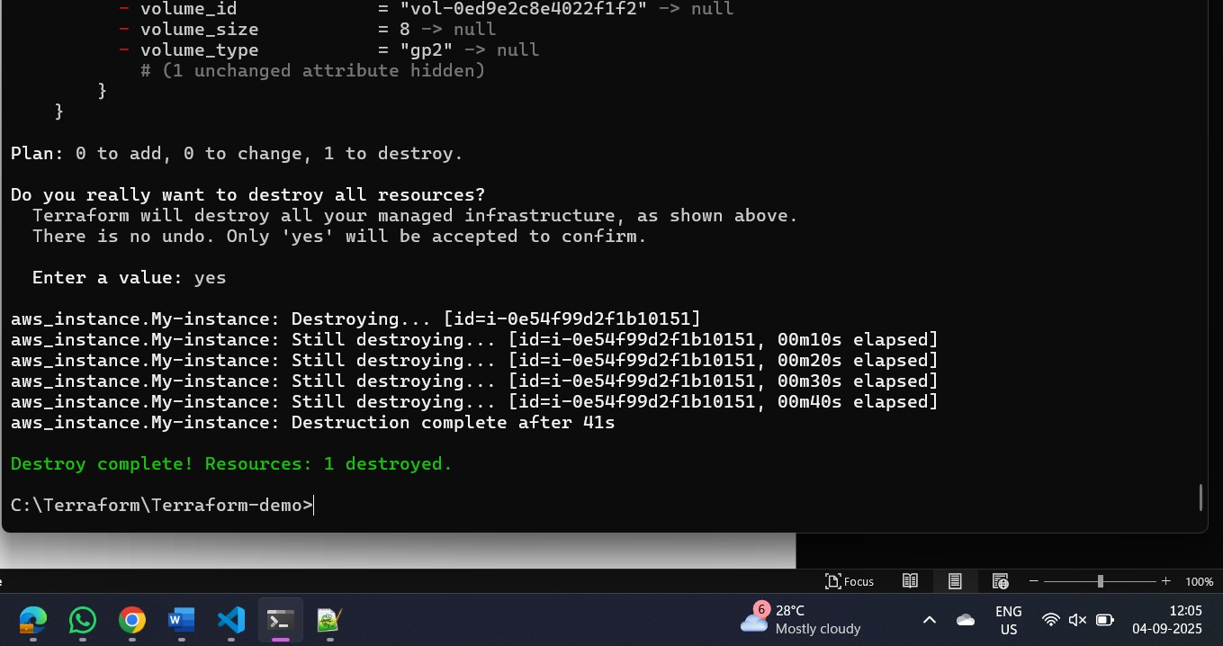
Type yes when prompted.
Notes:
Customize the instance.tf file to provision different AWS resources.
Explore the Terraform AWS provider documentation for additional AWS resources and configuration options.
Always be cautious when running terraform destroy to avoid accidental resource deletion.
This exercise provides a basic introduction to using Terraform with the AWS provider. Feel free to explore more complex Terraform configurations and resources based on your needs.

